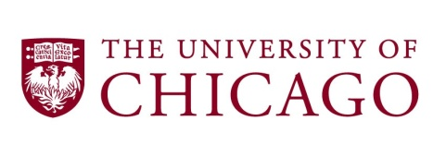 | Effective 07/2010  Page 1 of 2  Questions about this form? Contact HR, Office of Labor Relations:  Phone: 773-702-4040

BONUS REQUEST FORM - LOCAL 743 EMPLOYEES

TO BE USED ONLY FOR - Supervisors requesting a special bonus payment for a current Local 743, I.B.T. employee

Employee ID: ________________ Employee Name: ________________________________________

Department #: _______________ Department Name: ______________________________________

Job Code: ____________ Job Title: _____________________________________ HR/Wk: ________
Bonus Amount: $ __________ Account # ErnType Acct. Amt.

__________________ BPY $ ________

Select one or more of the following:

Exceptional Achievement (acknowledgement of a major innovation that resulted in increased productivity and/or quality of the unit).

Explain the circumstance:

Exceptional Service (acknowledgement of extraordinary circumstances that call for contributions that far exceed expectations).

Explain the circumstance:

Special Project(s) (acknowledgement of those requested to work on projects significantly and demonstrably different from their regularly-assigned duties).

Explain the circumstance:

Budget Savings (acknowledgement of productivity improvement or an innovation that resulted in budget savings beyond the employee’s regular job assignment).

Explain the circumstance

ALL FIELDS REQUIRED

Department Contact Phone Employee Date

U
Dean/Administrator Date Supervisor Date

HR Approval Date

INSTRUCTIONS: | Throughout the term of this agreement between The University of Chicago and Local 743, I. B.T. this form will be used to request bonus payments for union employees. Employees may be eligible for payments for exceptional achievements at the discretion of the University. Employees must be non-probationary and not be on a recorded disciplinary track.
ROUTING: | Bonus Request Form should be routed to Human Resources, Office of Labor Relations for approval. Forms will be processed and payments will be included in the next biweekly payroll.

